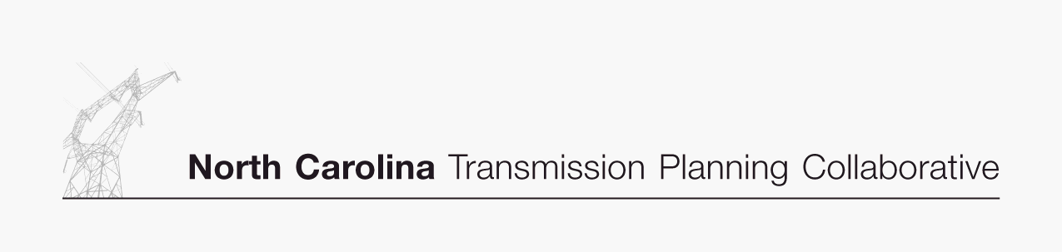

For Immediate Release, April XX, 2007 DRAFT

N.C. Collaborative Regional Transmission Plan update reduces overall cost

RALEIGH, N.C. -- Participants in the North Carolina Transmission Planning Collaborative (NCTPC) have published a Supplemental Report to the original 2006 Collaborative Transmission Plan for North Carolina to reflect updated information. The update provides for a better overall technical transmission solution, while lowering overall implementation costs by more than $100 million.

Participants include Duke Energy Carolinas, Progress Energy Carolinas, North Carolina Electric Membership Corporation and ElectriCities of North Carolina.

On January 25, 2007, the Participants achieved a major milestone with the publication of their first single Collaborative Transmission Plan for North Carolina. The N.C. regional planning study includes a base reliability analysis as well as analysis of potential resource supply options. The resource supply analysis provides the opportunity to evaluate transmission system impacts for various resource supply options to meet future native load requirements. The purpose of the supplemental analysis was to address one additional resource supply option, a transfer of 1,200 MW from Duke to Progress Energy’s eastern N.C. service area, which was not included in the original 2006 study due to time constraints.

The updated 2006 Collaborative Plan is now composed of 14 major transmission projects totaling $294 million in capital investment (down from $400 million as initially proposed). Major projects are defined as those requiring investments of more than $10 million. In addition, the supplemental analysis identified that the incremental cost to import 600 MW from Duke into Progress Energy’s eastern service area would be reduced from $131 million to $68 million, while the incremental cost to import 1,200 MW was estimated to be $71 million. The 2006 Supplemental Report can be viewed on the NCTPC Web site at www.nctpc.org/nctpc under the Reference Documents section.

The major transmission projects identified in the updated 2006 Collaborative Transmission Plan are expected to be implemented over the 10-year planning horizon by the transmission owners to preserve system reliability and improve economic transfers. These planned projects are part of an annual planning process and are subject to change based on evolving system conditions. Work is continuing on the 2007 study and those Collaborative Transmission Plan results are expected to be published at the end of this year.

“The NCTPC is an excellent example of how the regional planning obligation can be coordinated with existing state planning processes,” said Jim Kerr, commissioner on the North Carolina Utilities Commission and president of the National Association of Regulatory Utility Commissioners (NARUC).

The NCTPC was established in May 2005 to provide the participants and other stakeholders an opportunity to participate in the electric transmission planning process for North Carolina, and to develop a single coordinated transmission plan for North Carolina electric utilities that includes reliability and enhanced transmission access considerations. Among the group’s top priorities is the goal of balancing costs, benefits and risks associated with the use of transmission and generation resources.

“The NCTPC has been successful in bringing the participant utilities together to better plan to ensure reliability and access to benefit the state,” said Clay Norris, NCTPC chair, ElectriCities of NC, Inc.

The NCTPC process includes active participation of other market participants and other stakeholders through a Transmission Advisory Group (TAG), which is open to all interested parties. If you are interested in joining the TAG or to receive future information related to this NCTPC process, you can go to the NCTPC Web site at www.nctpc.org/nctpc and sign up for the TAG distribution list.

The NCTPC process includes the use of an Independent Third Party (ITP) consultant to act as a facilitator for the development and conduct of the NCTPC process. This role includes chairing the TAG and soliciting input from the other stakeholders through the open TAG meetings. The ITP consultant for the NCTPC process is Gestalt-llc, www.gestalt-llc.com.

If you have any comments or questions on the NCTPC Process or specifically on the 2006 Collaborative Transmission Plan Study Report, please contact Clay Norris, NCTPC Chair (via email cnorris@electricities.org or phone 919-760-6352).

For media inquiries, please contact corporate media relations at each entity:

Duke Energy Carolinas
-Mary Kathryn Green, 704-382-8356; mkgreen@duke-energy.com

ElectriCities of NC (municipals)
-Rebecca Agner, (919)760-6334; ragner@electricities.org

Progress Energy Carolinas
- Mike Hughes, (919) 546-7274; mike.hughes@pgnmail.com

NCEMC (co-ops)
- Jane Pritchard, (919) 875-3104, jane.pritchard@ncemcs.com

